LABORATORIO ARTIGIANO RETI
di ARCHETTI CARLO
Reti da Pesca – Sport – Caccia
Recinzione Impianti Sportivi
Antinfortunistica – Acquacoltura
25058 SULZANO (BS) – Via Tassano, n. 8
Tel. e Fax 030/985290 – Tel. Ab. 030/985191
Cell. 328 0562071 c.f. RCHCRL64C01F532U – P.I. 03216410179
www.retiarchetti.it – info@retiarchetti.it
www.retiarchetti.com – info@retiarchetti.com
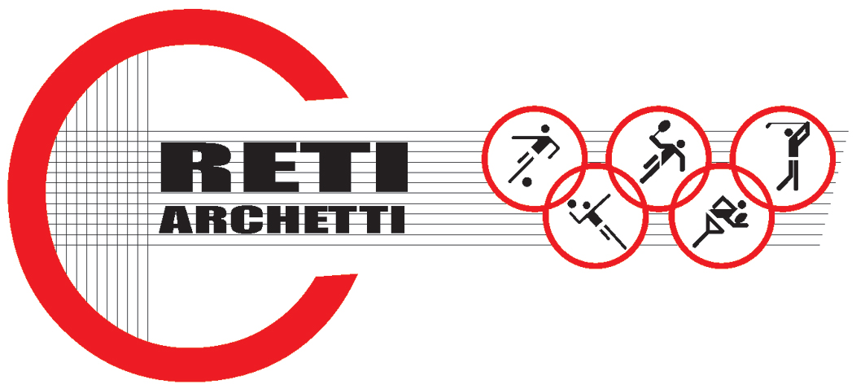

TECHNICAL DATA SHEET ART.CODE: B 3

NET MADE OF POLYETHYLENE,KNOTTED, STABILIZED AGAINST UV RAYS, MESH mm 120 x 120, THICKNESS mm 3

STATIC TESTS tests carried out with a polyethylene net, knotted, green colored (title 3x13x600 denier and mesh mm. 120) according to Standard EN 1263-1.
Hereafter the results obtained with tests on samples of a brand new net, dimensions 3 x 3 m:

AVERAGE ULTIMATE STRENGTH: 485 daN

Technical features

- MATERIAL: H.D. Polyethylene, stabilized against UV rays, water repellent.
- AVAILABLE COLORS: green
- YARN THICKNESS: 3 mm
- NET: squared mesh
- MESH: mm 120 x 120
- WEIGHT: g. 54/sq m
- EDGE STRIP: with a 6 mm polyethylene braid.
- FUSION TEMPERATURE: 120° C
- MIN. USE TEMPERATURE: – 40° C
- WATER ABSORPTION: 0,01% - WATER REPELLENT –
- MOTH RESISTANCE = ABSOLUTE
- MOULD RESISTANCE = ABSOLUTE
- ABRASION RESISTANCE = EXCELLENT
- MINERAL ACIDS = RESISTANT
- ORGANIC ACIDS = RESISTANT
- ALKALI = RESISTANT
- OIL = RESISTANT

Each net can be manufactured with length and width on customer request. Nets are complete with a reinforced strip along the edge with a 6 mm braid sewed to the net. A piece of rope at the angles makes the installation easier.

